**ASSIGNMENT – 2B**

**Activity 11:**   
For activity #11, you must re -create a new version of the Web site you created for Assignment   
1A (activity #3), only this time you must use only CSS to achieve the same design   
Use the tables as depicts in the following figure and apply CSS style for the same   
   
• Using styles assign table height and width and some styles for border as of your   
choice.   
• Apply center text align for the table data   
• Include some control the space between the border and the content in a table   
• Highlight table rows content on mouse over with grey color   
Note: Include any two properties of your choice(minimum) and use style as container

**Aim:**  
To recreate a new version of the website from Assignment 1A (Activity #3) using only CSS to achieve the same design. The objective is to style a table by setting its height and width, applying custom border styles, and ensuring center-aligned text in the table data. Additionally, control the spacing between the content and the border within the table, and implement a hover effect to highlight table rows with a grey color. The design should incorporate at least two custom CSS properties of choice, applied within a container for proper layout and styling.

**HTML tags and the attributes used:**

| **HTML Tags Used** | **Attributes Used** |
| --- | --- |
| <!DOCTYPE html> | lang (in <html>) |
| <html> | lang (value: "en") |
| <head> | None |
| <meta> | charset (value: "UTF-8"), name (value: "viewport"), content (value: "width=device-width, initial-scale=1.0") |
| <title> | None |
| <body> | None |
| <header> | None |
| <h2> | None |
| <div> | None |
| <table> | None |
| <tr> | None |
| <td> | rowspan, colspan, class, style |
| <a> | href, target |
| <img> | src, alt |
| </body>, </html> | None |

**Code:**

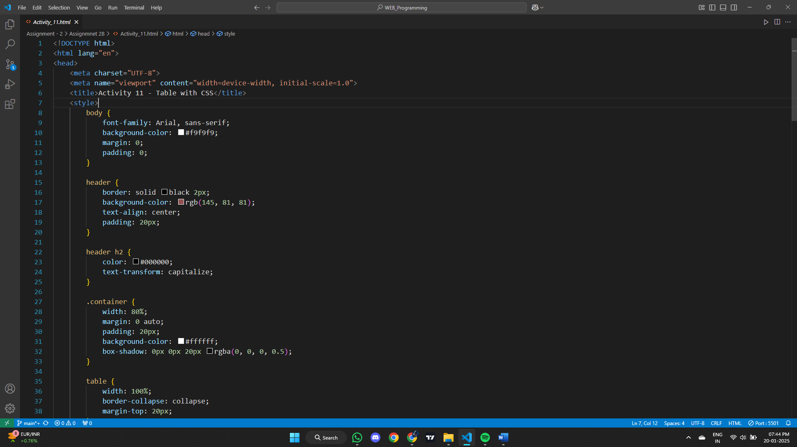

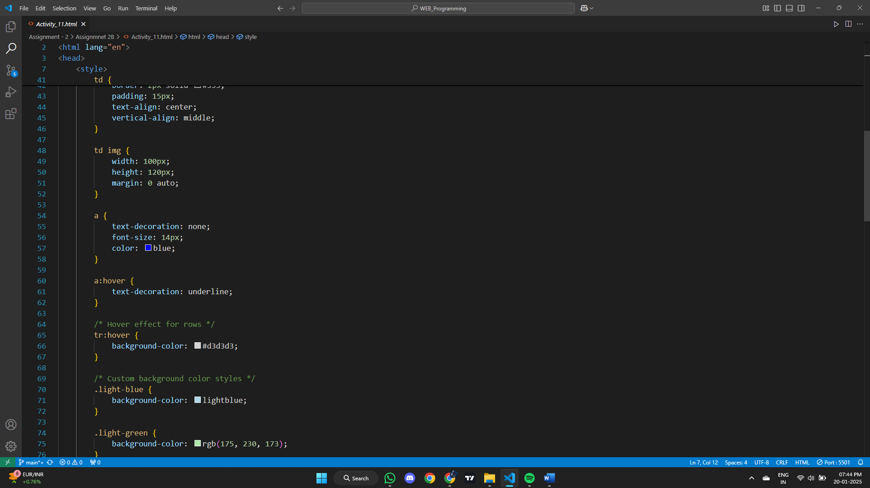

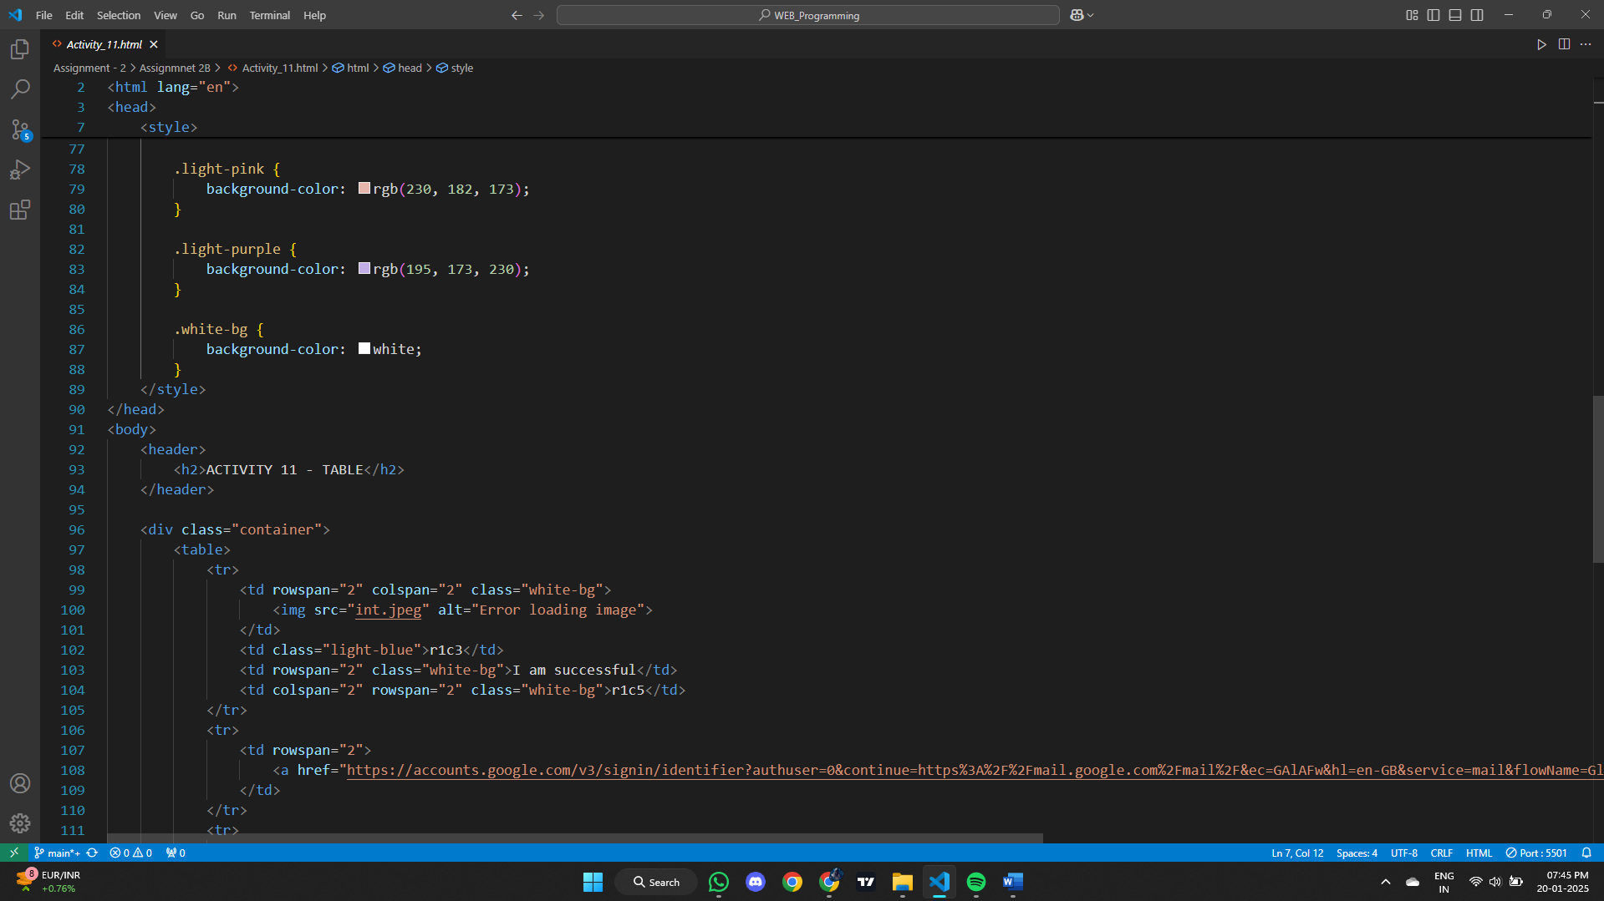

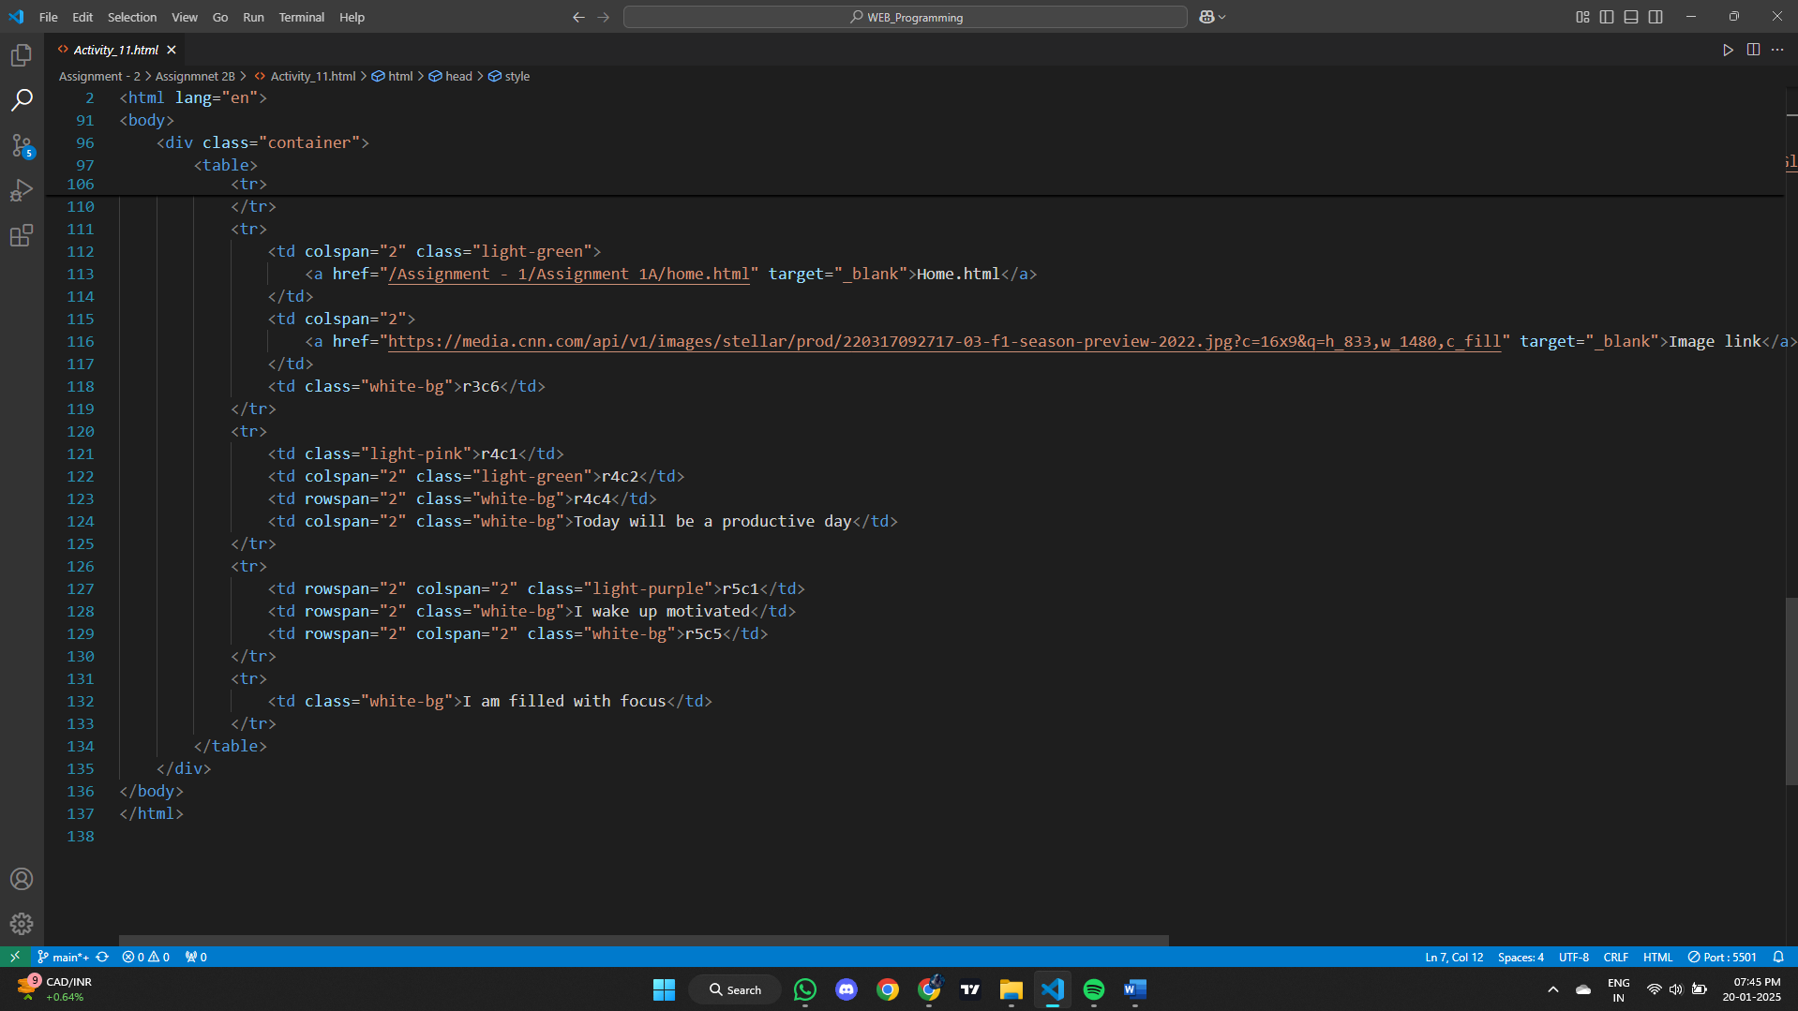

**Output:**

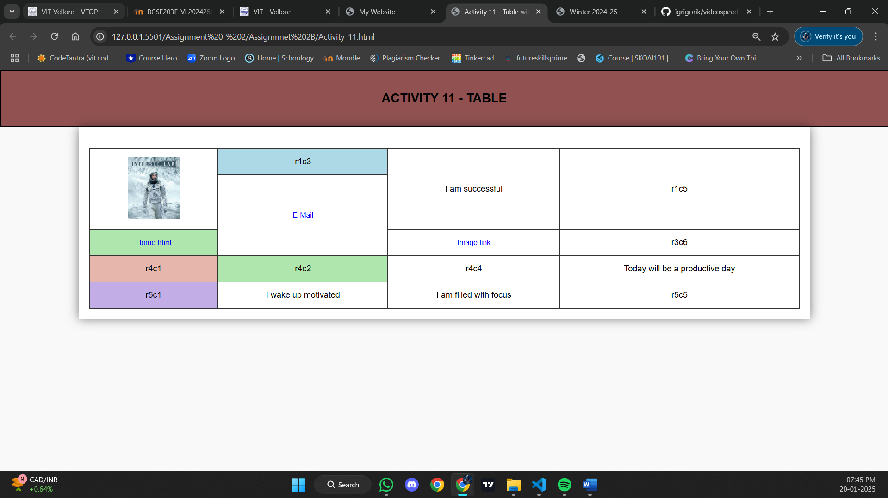

**Result:**

Thus, a web page design to replicate the above table and the output was verified.

**Activity 12:**

For activity #12, you must re -create a new version of the Web site you created for Assignment   
1C (activity #8), only this time you must use only CSS to achieve the same design   
CSS constraints   
• Use respective selector for designing layout temple as per your choice.   
• Design customized banner image for home page   
• Apply CSS for navigation page and hyperlinks can be styled with any CSS property   
(e.g. color, font-family, background, etc.).   
• Apply styles for signup and login pages.   
• Apply box model and position properties which is applicable for your design   
Note: Choose the layout design of your choice and use external CSS file

**Aim:**  
To create a table-based layout for a webpage using only CSS, following the structure from Assignment 1A (Activity #3). The goal is to apply CSS styles to the table, including setting its height and width, defining border styles, centering text within the table cells, controlling spacing between the content and the borders, and adding a hover effect to highlight rows. The design will also include at least two custom CSS properties of your choice, applied to enhance the layout and style of the page.

**HTML tags and attributes used:**

| **HTML Tag** | **Attributes** |
| --- | --- |
| <!DOCTYPE html> | N/A |
| <html> | lang="en" |
| <head> | N/A |
| <meta> | charset="UTF-8", name="viewport", content="width=device-width, initial-scale=1.0" |
| <title> | N/A |
| <link> | rel="stylesheet", href="style.css" |
| <body> | N/A |
| <header> | N/A |
| <h1> | N/A |
| <hr> | N/A |
| <nav> | N/A |
| <h3> | N/A |
| <a> | href="#home", href="#activity", href="#blog", href="#contact", target="_blank" |
| <section> | id="home", id="activity", id="blog", id="contact" |
| <p> | N/A |
| <ul> | N/A |
| <strong> | N/A |
| <a> | href="Assignment - 1/Assignment 1A/home.html", target="_blank", href="Assignment - 1/Assignment 1A/list.html", href="Assignment - 1/Assignment 1A/table.html", etc. |
| <video> | width="320", controls |
| <source> | src="Assignment - 1/Assignment 1B/GitHub.mp4", type="video/mp4" |
| <form> | action="https://img.freepik.com/premium-vector/thank-you-caligraphic-vector-illustration-concept_1253202-40937.jpg?semt=ais_hybrid", target="_blank" |
| <label> | for="name", for="email", for="message" |
| <input> | type="text", type="email", id="name", id="email", placeholder="Enter your name", required, id="email", placeholder="Enter your email", etc. |
| <textarea> | id="message", name="message", placeholder="Write your message", required |
| <button> | type="submit", id="submit" |

**Code:**

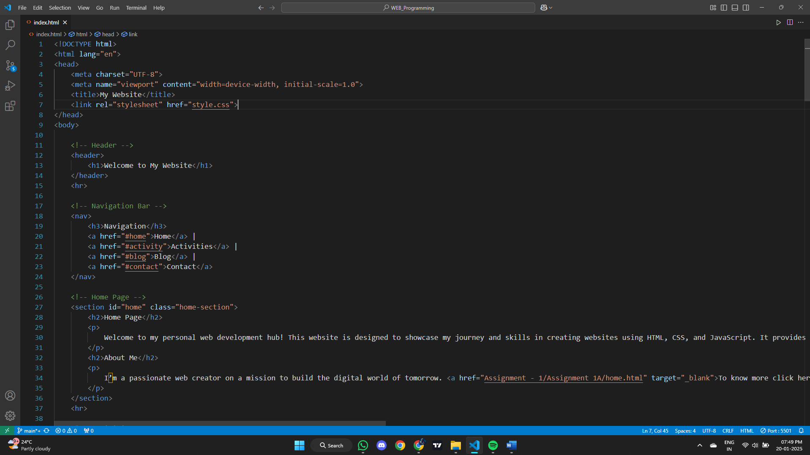

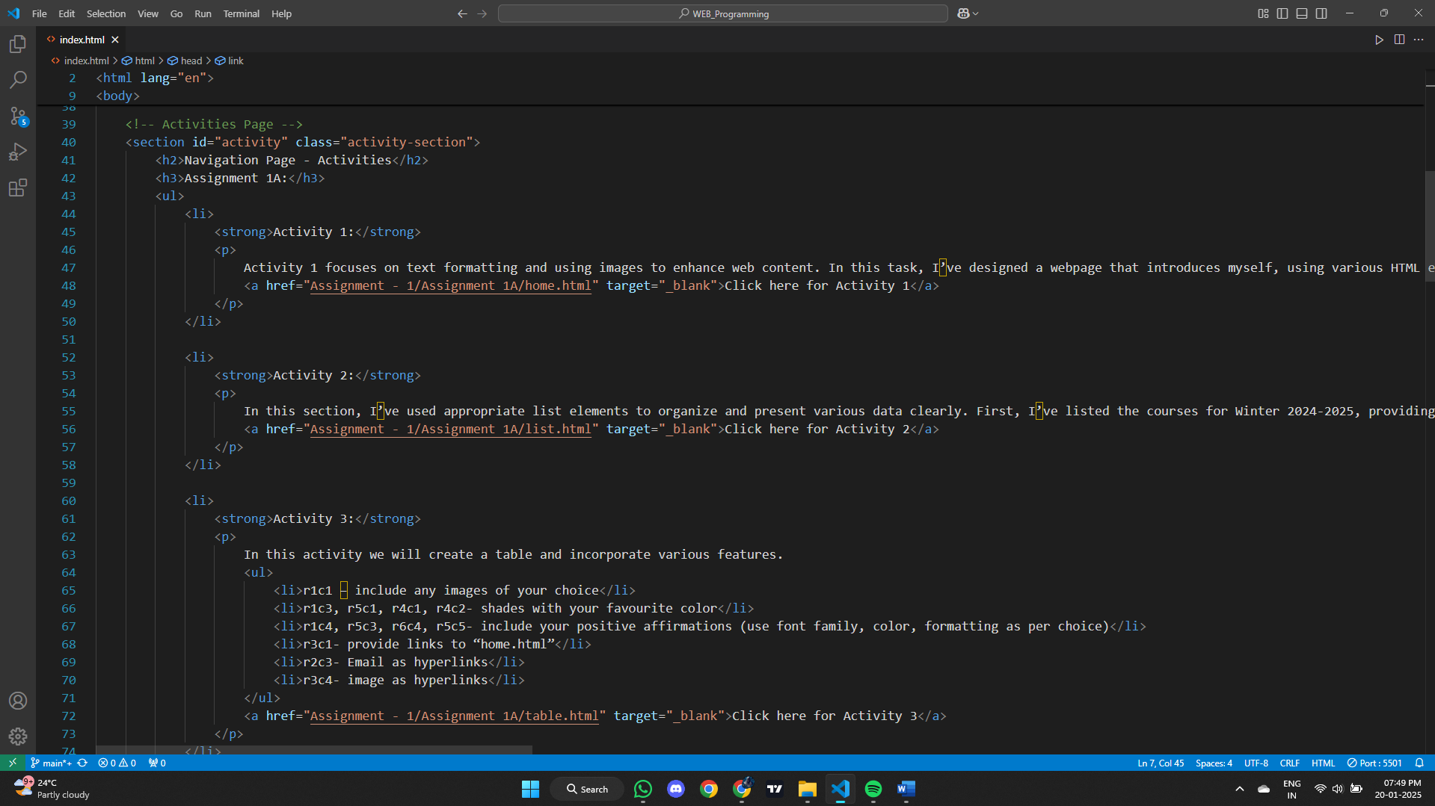

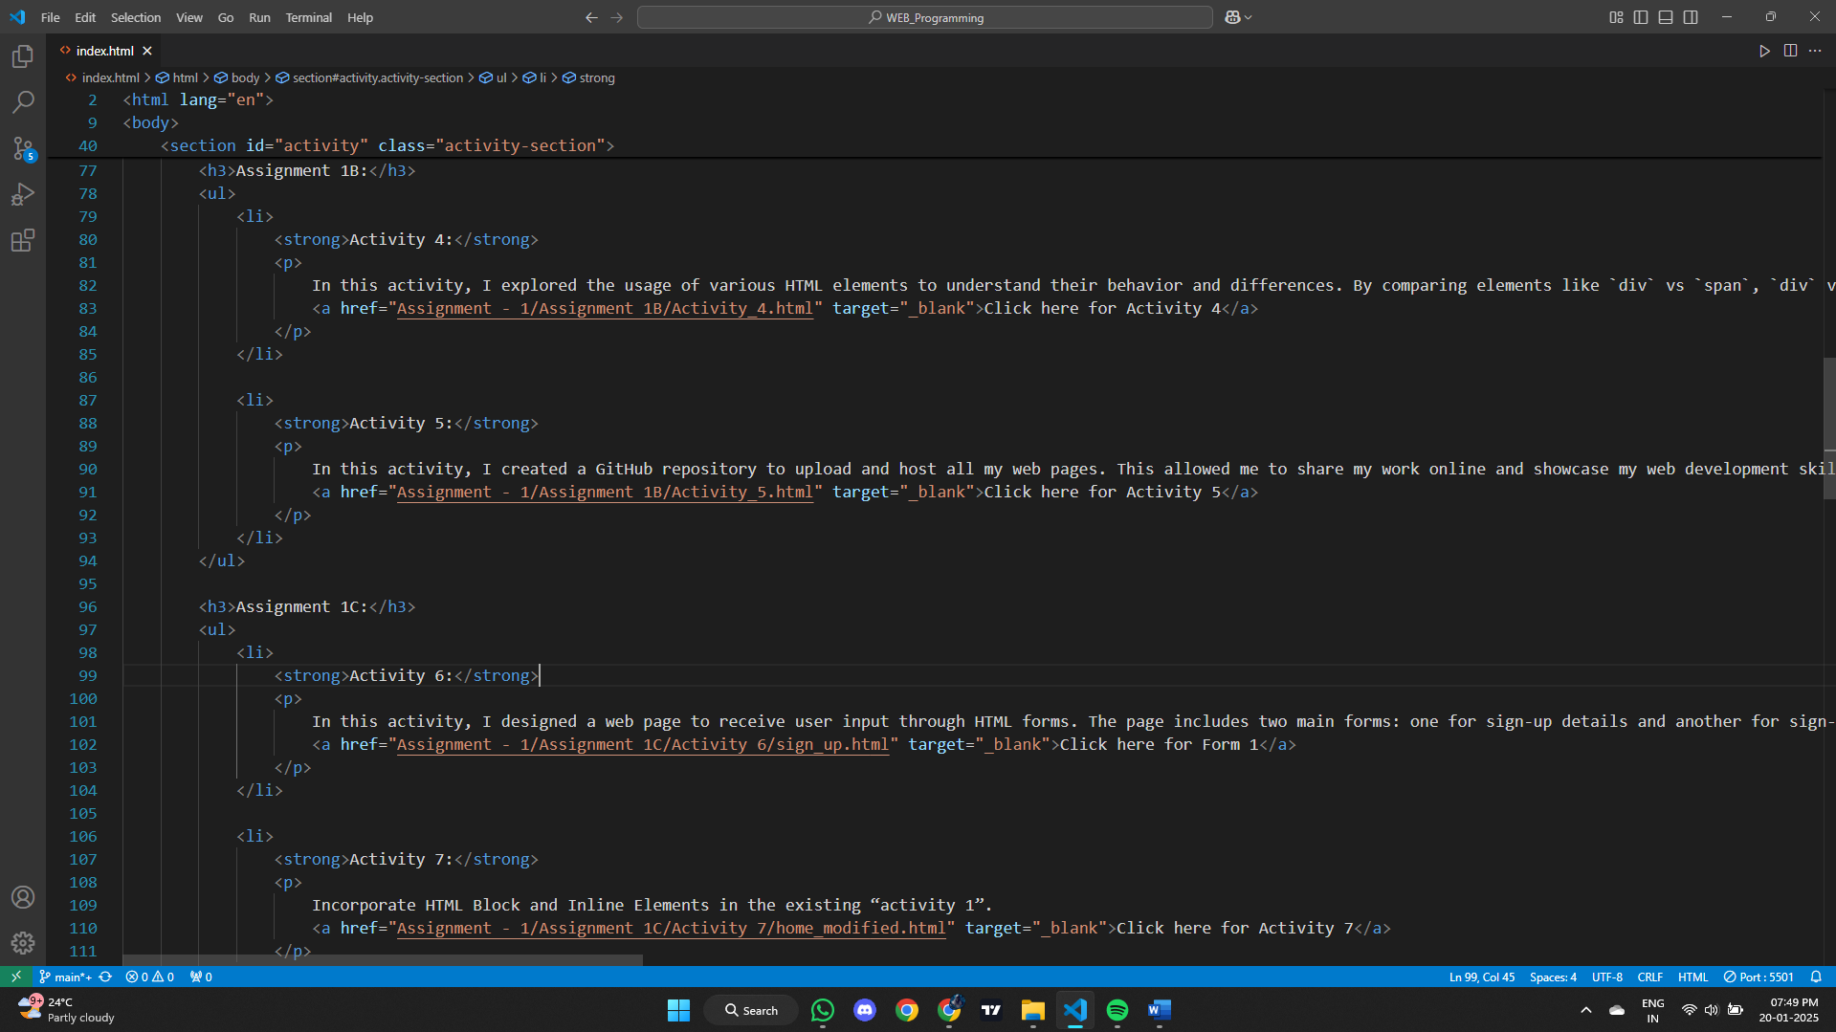

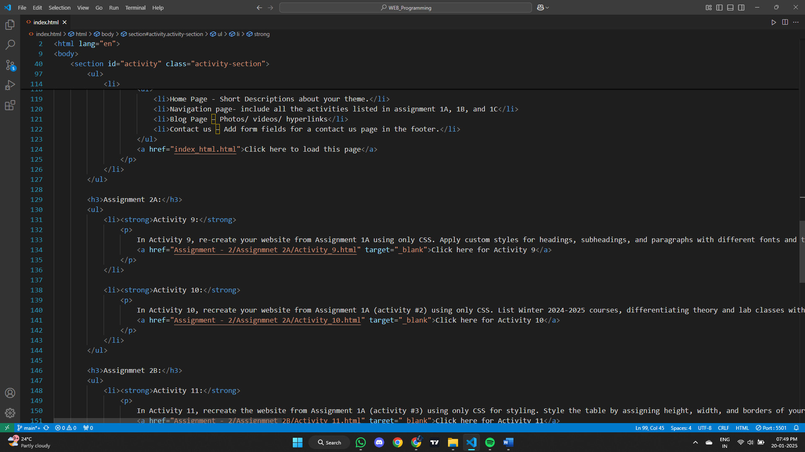

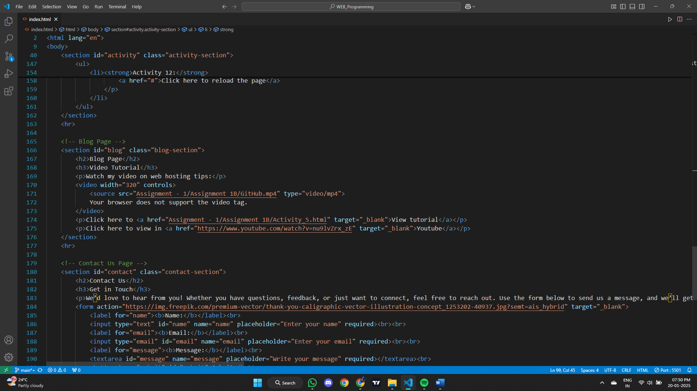

**Output:**

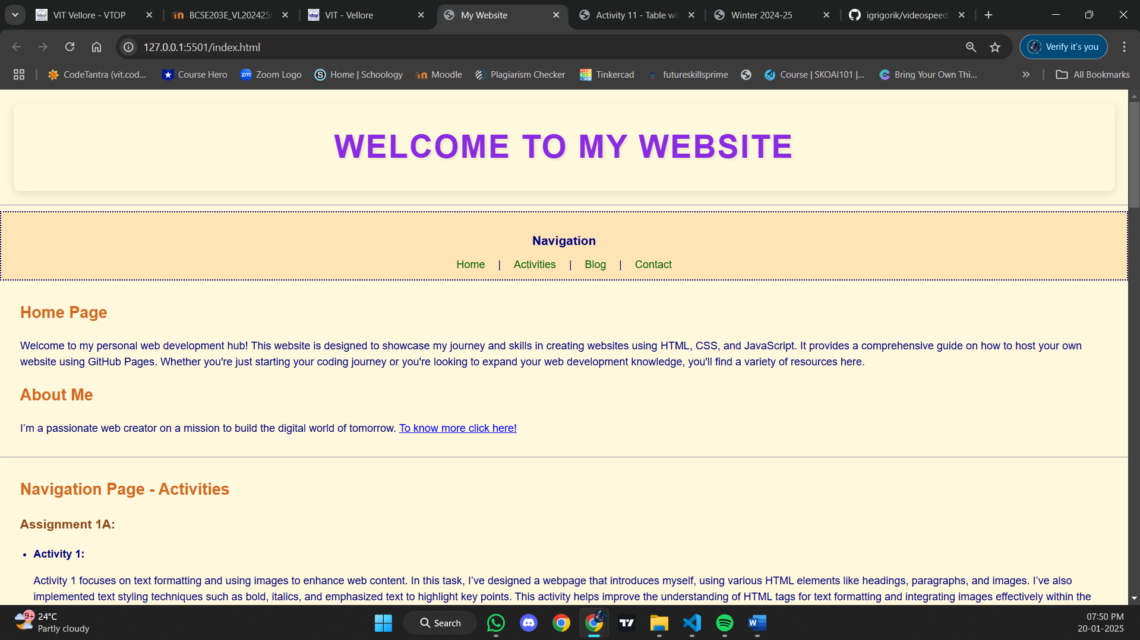

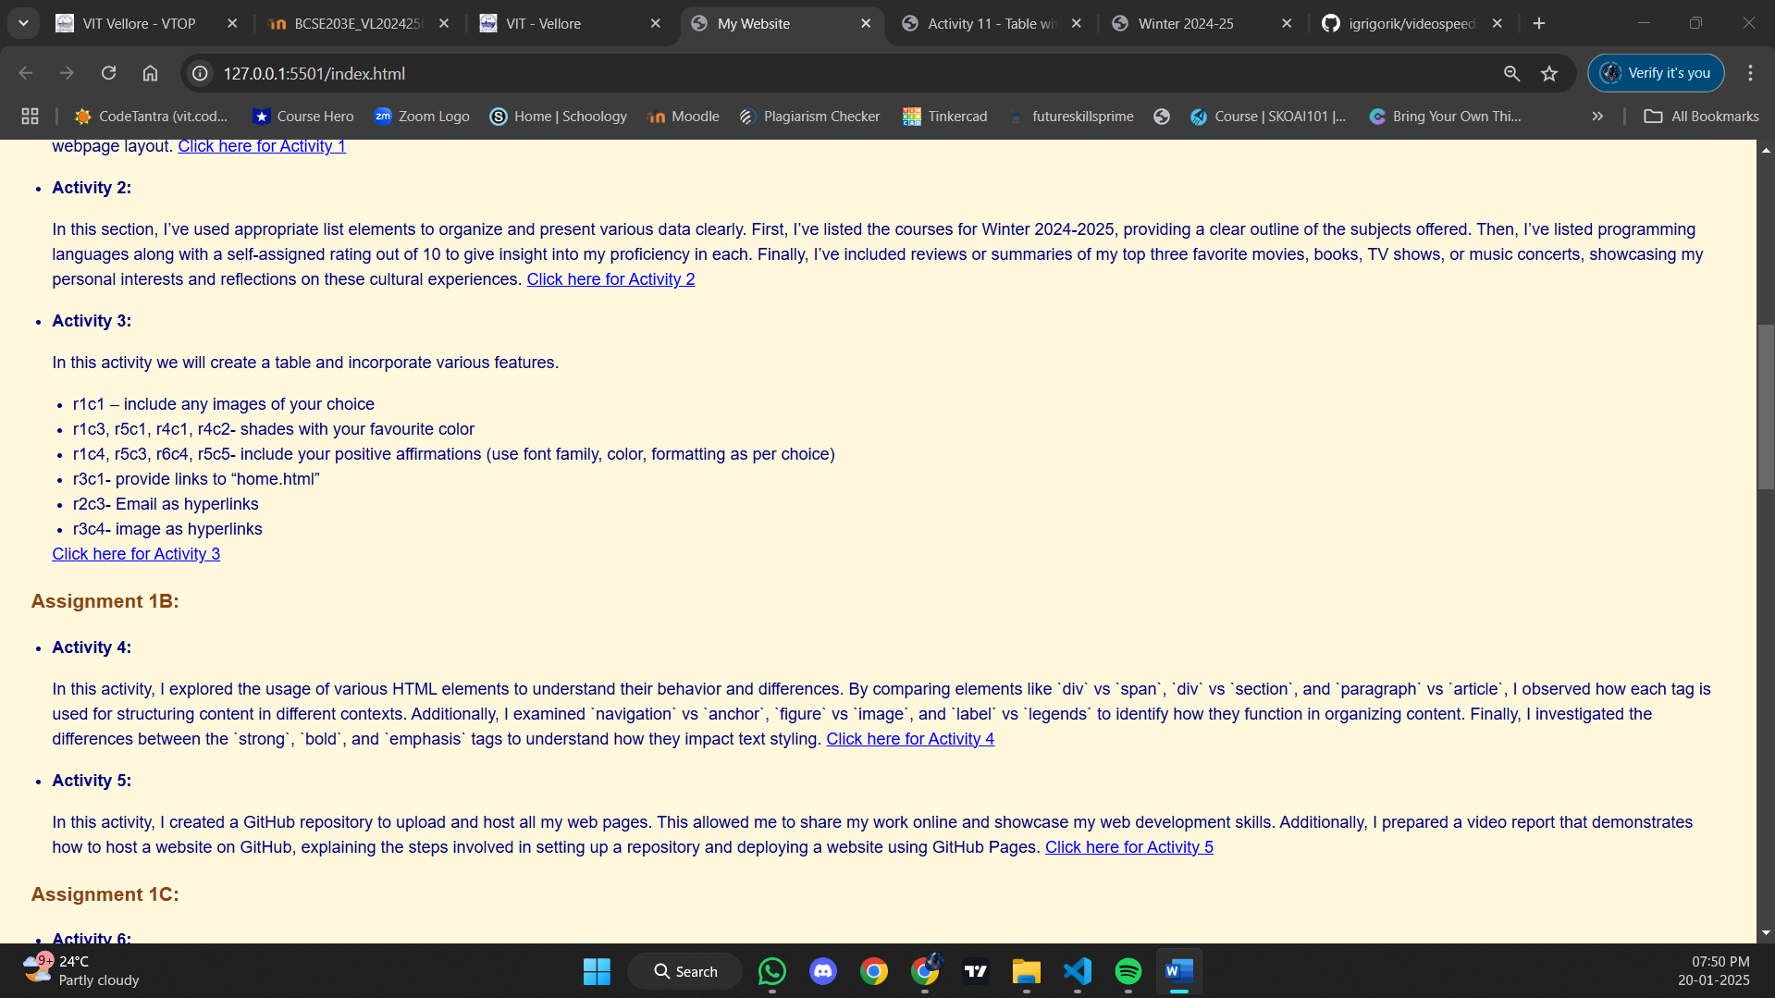

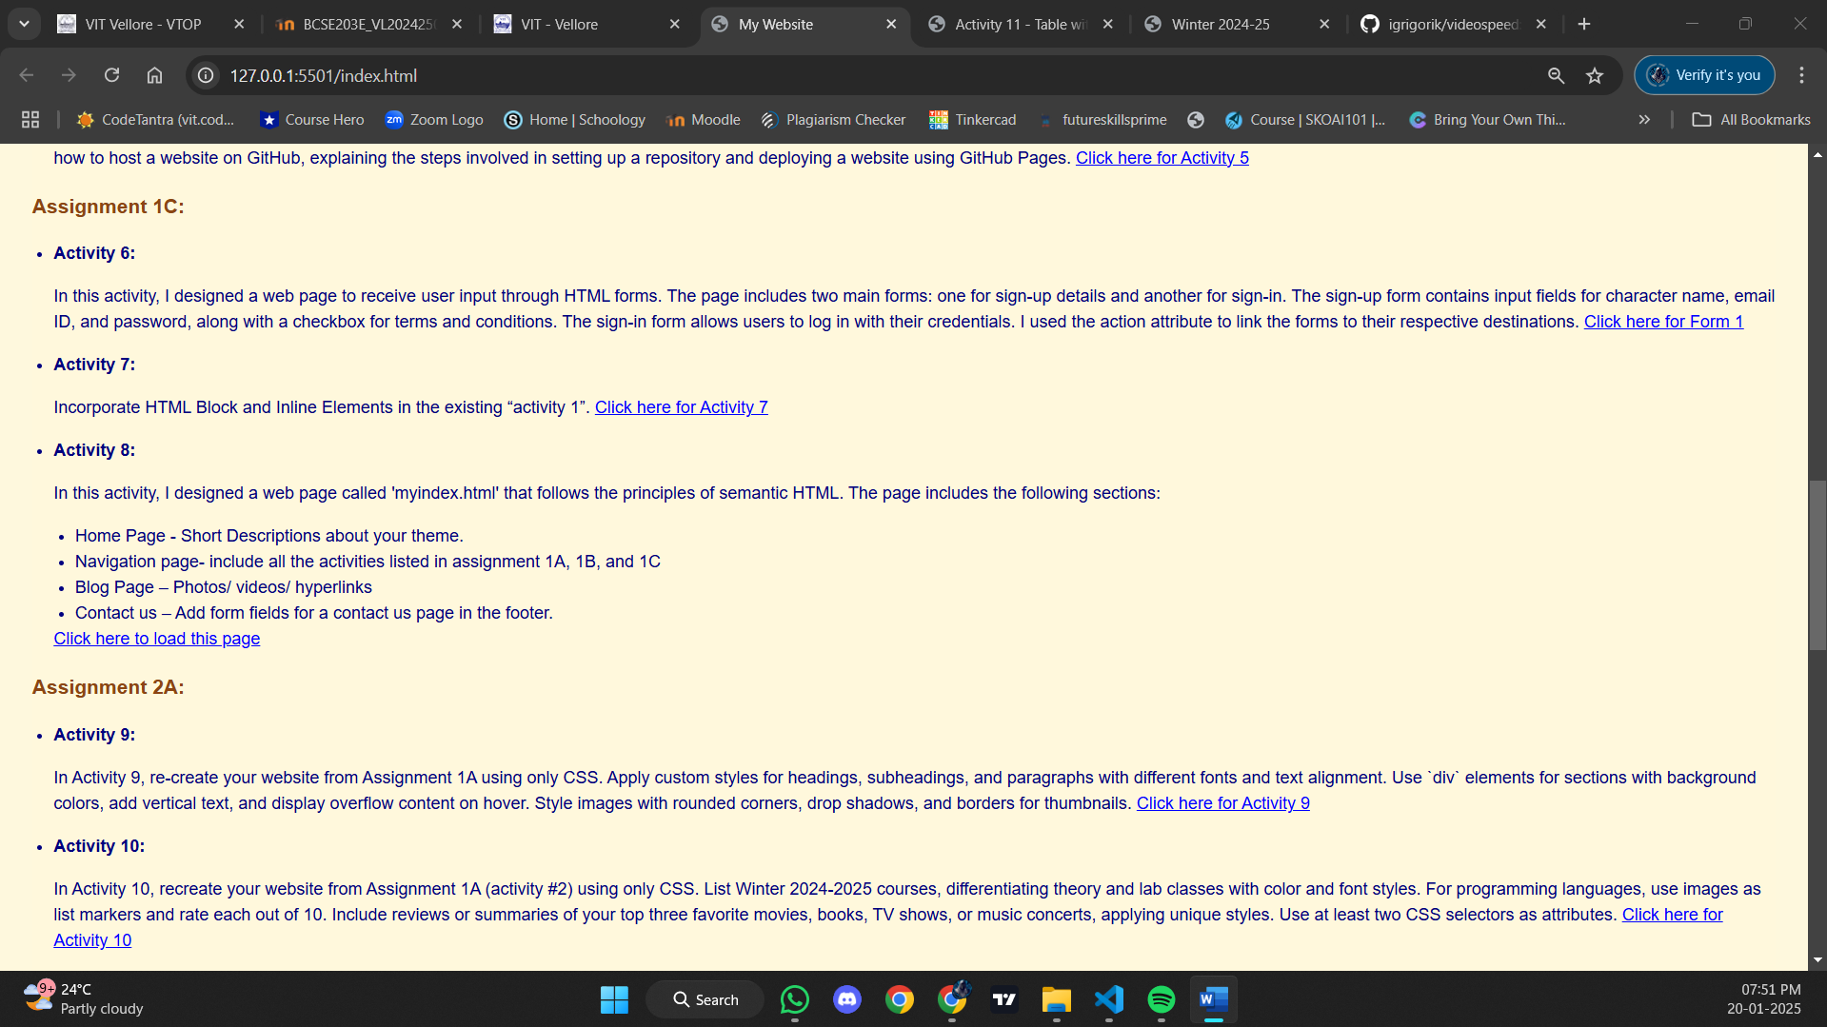

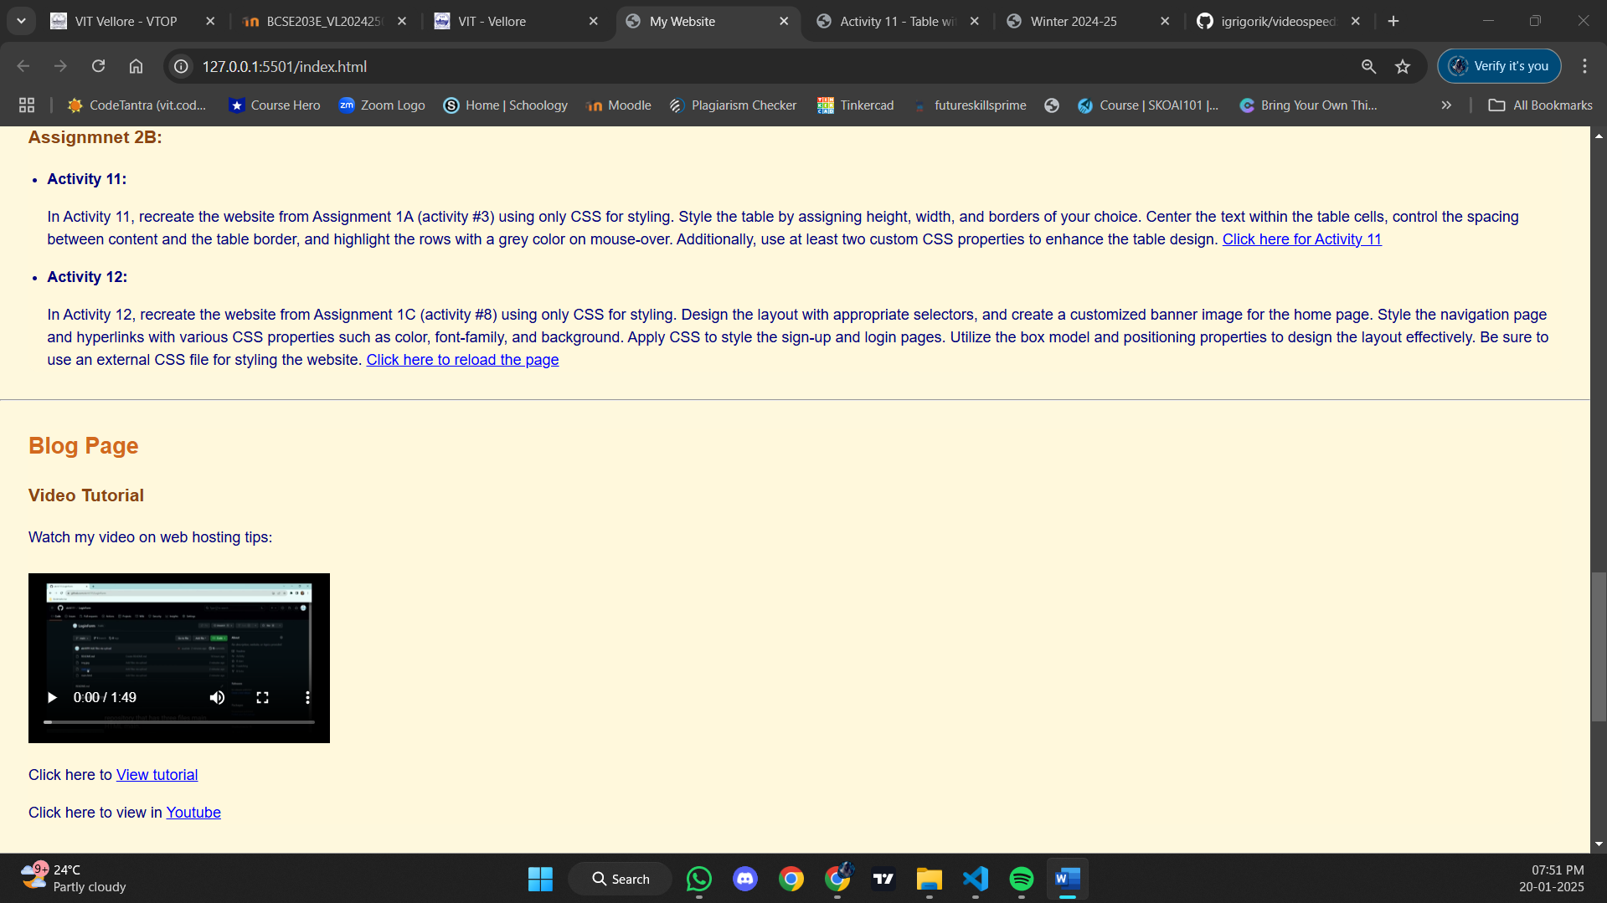

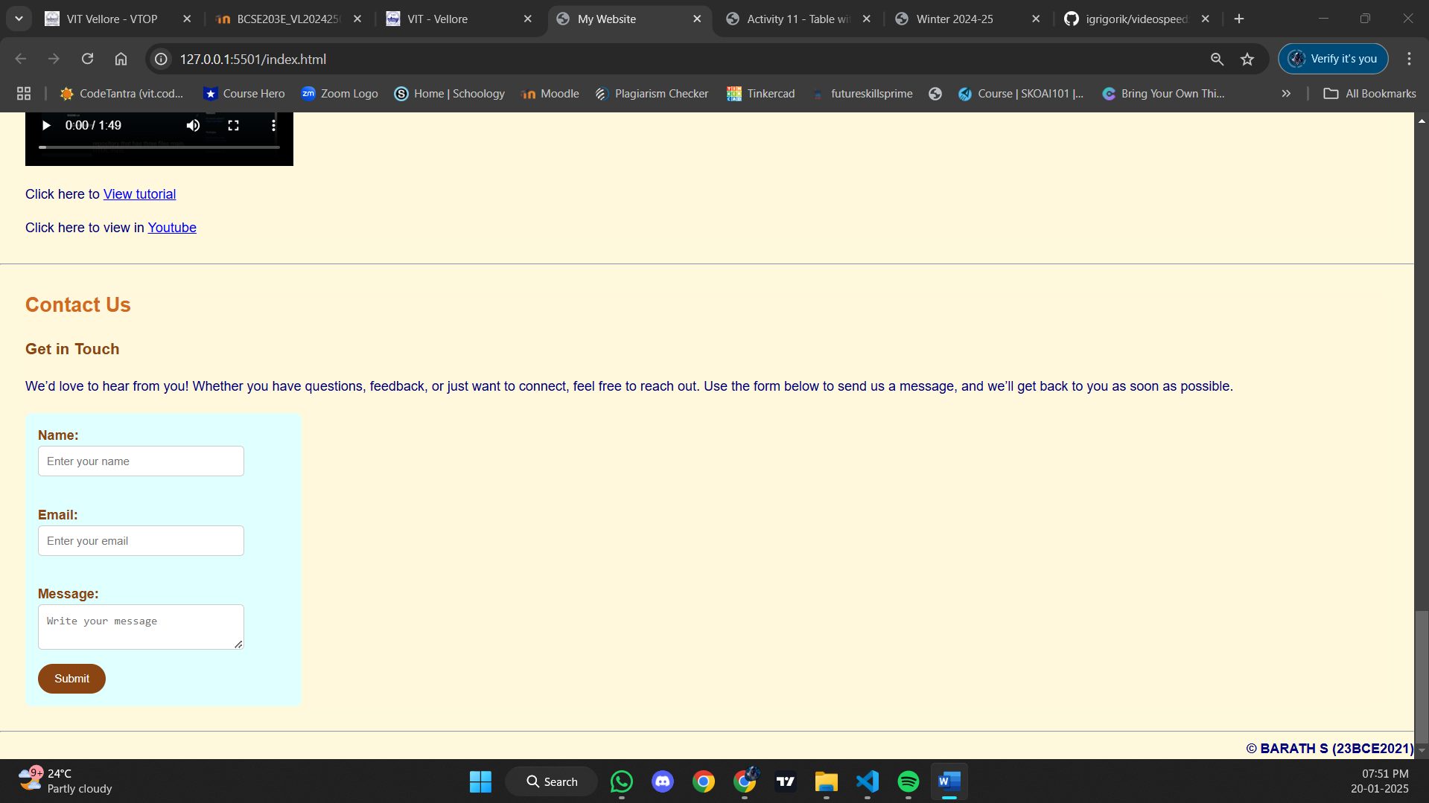

**Result:**

Thus, a web page design to replicate the above table and the output was verified.